ARO Progress Report

# Introduction

## Recap

Performance is very good on average but strong session-to-session variability.

Run-by-run temporal slicing is best.

Sensitivity is a nice way to show information coding in the brain with caveats.

## Motivate

Goal is to “read out” an internal cognitive variable: task difficulty.

Use balanced stimulus with minimal low-level visual cues.

Utilize different cueing schemes to encourage top-down or bottom-up forms of visual attention.

Analysis will evaluate the use of ICNs to improve performance.

# Methods

## Stimulus

|  |  |
| --- | --- |
| (a) | (b) |

Figure . Example frames from the stimulus during task (a) and rest (b) phases.

We built a new stimulus from the ground up using the Unity game engine (<http://unity3d.com>) in order to improve both the realism of the virtual environment and the degree of control over presentation. New high-resolution models and textures were used to drastically improve the visual quality of the environment over the previous iteration. Additionally, characters were given improved animations and programmed with basic artificial intelligence to increase the naturalness of the environment. Given our long-term interest in PTSD, the virtual environment is intended to reflect real-world environments encountered by our military personnel. It is similar to the virtual Iraq used in recent virtual reality exposure therapy experiments (Gerardi, Rothbaum, Ressler, Heekin, & Rizzo, 2008).

The stimulus alternated between task periods and rest periods, which lasted for 30 seconds each. During the rest period, the subject’s perspective moved along fixed paths through the virtual town (Figure 1(b)). During the task period, the subject’s perspective was stationary, but a large group of characters randomly milled around the scene while avoiding collisions with each other (Figure 1(a)).

The subject was tasked with identifying when a character draws a firearm. Periodically (every 2–6 s), one of the characters milling around the scene was selected at random to draw a firearm and then holster it after a fixed period of time. The subject was instructed to press a button whenever he identified a character with a drawn firearm. A correct response was recorded if the subject pressed the button during the presentation period and an incorrect response was recorded if the subject failed to press the button before the firearm was holstered or the subject pressed the button when no character had drawn a firearm.

Difficulty of the task could be controlled by adjusting the type of firearm the characters drew (pistol, rifle, or RPG), the distance of the character from the subject’s perspective, and the duration that the firearm was presented for. Extensive psychophysics data was collected to determine the relationship between these parameters and the subject’s probability of success. We found a considerable amount of variability in the psychophysics data was explained by what we call total visibility: the visible area of the object to be detected in pixels integrated in time across the duration of its presentation (with the resulting units being pixel-seconds). Therefore, we calculated total visibility in real time to adjust the presentation period of the firearm. This allowed us to compensate for the variance introduced by partial and total occlusion of the firearm caused by the randomly moving characters. To create a single difficulty control, we held the type of firearm constant and linked total visibility to presentation distance, i.e., for a hard trial the character would be presented further away and with a smaller total visibility.

We collected fMRI data using 3 different variants of the task. In the first variant, difficulty was held constant during each 30-second block and the subject received a cue indicating the difficulty of that block before it started. Difficulty was only controlled by distance and the firearm presentation period was fixed. In the second variant, difficulty varied continuously during the block and no cue was presented. Difficulty was controlled using both distance and total visibility to adjust the presentation period. In the third variant, difficulty was held constant during each block and the subject was cued. Difficulty was controlled using both distance and total visibility to adjust the presentation period.

The task and difficulty parameters were designed to limit the correlation between low-level visual cues and task difficulty. Although the distance of the character selected to draw a firearm varied with difficulty, the average distance, density, and speed of the characters remained the same in all difficulty settings. The character with the firearm moved and behaved exactly like the other characters. The only difference between the difficulty settings is the size and location of the firearm itself, which has a very small size and contrast compared to the entire scene.

## fMRI

Moved to new scanner.

Allows us to collect higher resolution data over a larger area of the brain without overheating.

Makes it easier to reliably collect more runs per session.

### Functional

EPI, grappa acceleration factor 2, 2 mm isometric voxels, TR = 2.5 s, 60 slices, whole brain.

Number of volumes, runs, and sessions.

MrVista preprocessing: motion correction, slice timing correction

### Resting State

EPI, grappa acceleration factor 2, 2 mm isometric voxels, TR = 2.5 s, 60 slices, whole brain.

Number of volumes, runs, and sessions.

MrVista preprocessing: motion correction, slice timing correction

FSL Melodic with 70 components for ICA decomposition

## Analysis

Calculation of targets from results file.

Feature selection using ANOVA and ICA component masks

Machine learning using SVM and NN

Accuracy estimation from cross-validation.

Sensitivity maps for SVM and NN

Adjusted sensitivity maps to account for potential “large signal” problem

# Results

## Psychophysics

Aggregate plots for subject psychophysics data

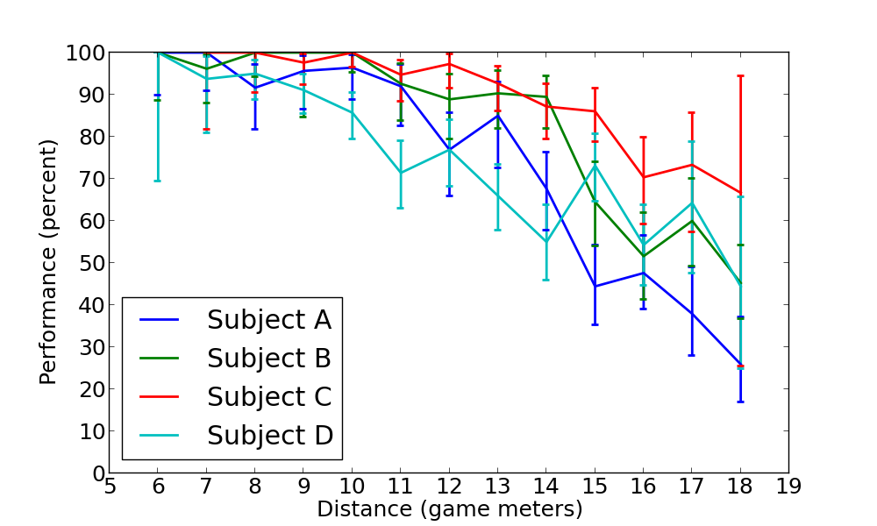

## Machine Learning

Average and individual cross-validated accuracy and confusion matrices for SVM and NN using ANOVA feature selection

|  |  |  |  |  |  |  |
| --- | --- | --- | --- | --- | --- | --- |
| Stimulus Variant | Cued, no visibility control | | Non-cued, visibility control | | Cued, visibility control | |
| Subject | A | D | A | B | C | D |
| Accuracy | 51% | 51% | 47% | 43% | 50% | 47% |

Sensitivity maps for SVM and NN using ANOVA feature selection

|  |  |  |  |  |
| --- | --- | --- | --- | --- |
|  | Left Lateral | Left Medial | Right Lateral | Right Medial |
| Subject A |  |  |  |  |
| Subject B |  |  |  |  |
| Subject C |  |  |  |  |
| Subject D |  |  |  |  |

Preliminary results from ICA analysis

|  |  |  |  |  |  |  |  |
| --- | --- | --- | --- | --- | --- | --- | --- |
|  | Subject C | | | | | | |
| ICN | 4 | 5 | 7 | 8 | 10 | 11 | 21 |
| Accuracy | 43%* | 35% | 36% | 36% | 40%* | 35% | 37% |

Sensitivity maps for ICN 4 and 10

|  |  |  |  |  |
| --- | --- | --- | --- | --- |
| ICN | Left Lateral | Left Medial | Right Lateral | Right Medial |
| 4 |  |  |  |  |
| 10 |  |  |  |  |

# Discussion

Performance results promising for “readout” of internal brain state

Sensitivity maps consistent with readout of top-down and bottom-up information

Planned experiments will modulate attentional states and look for changes in distribution of sensitivity patterns

New analysis schemes to improve performance: individual ICNs, hierarchical ICNs, deep learning